H.T No
Regulations:
A22

Sreenidhi Institute of Science and Technology
(An Autonomous Institution)
Code No: 9BC01 Date: 05-August-2024 (FN)

B.Tech I-Year II- Semester External Examination, August-2024 (Regular & Supplementary)
ENGINEERING GRAPHICS (CSE,IT,CS and DS)

Time: 3 Hours Max.Marks:60

Note: a) No additional answer sheets will be provided.
b) All sub-parts of a question must be answered at one place only, otherwise it will not be valued.
c) Missing data can be assumed suitably.
Bloom's Cognitive Levels of Learning (BCLL)

Remember | L1 | Apply | L3 | Evaluate | L5
Understand | L2 | Analyze | L4 | Create | L6

Part - A Max.Marks: 6x2=12

Answer all QUESTIONS, EACH QUESTION CARRIES 2 MARKS.

 |  | BCLL | CO(s) | Marks
1 | What is meant by ‘Eccentricity’? State its values for conics. | L2 | CO1 | [2M]
2 | Differentiate between First Angle and Third Angle Projection methods. | L3 | CO2 | [2M]
3 | How are the Planes classified w.r.t. to VP and HP? | L2 | CO3 | [2M]
4 | State the purpose of sectioning a solid figure. | L1 | CO4 | [2M]
5 | What is meant by isometric scale? | L2 | CO5 | [2M]
6 | Differentiate between Isometric and Orthographic projections. | L3 | CO6 | [2M]

Part – B Max.Marks: 6x8=48
ANSWER ALL QUESTIONS. EACH QUESTION CARRIES 8 MARKS.

 |  | BCLL | CO(s) | Marks
7. | Draw a hyperbola when the distance from its focus and directrix is 50 mm and eccentricity is 3/2. | L3 | CO1 | [8M]
 | OR
8 | A circle of 50 mm diameter rolls along a straight line without slipping. Trace the locus of the point P on the circumference of the circle for one complete revolution. Name the curve. | L3 | CO1 | [8M]
9. | Draw the projections of the following points on the same ground line keeping the projectors 25 mm apart.  (a) Point A is 40 mm above H.P. and 25 mm in front of the V.P.  (b) Point B is 20 mm above H.P. and 45 mm behind the V.P.  (c) Point C is in V.P. and 40 mm above the H.P.  (d) Point D is 30 mm below the H.P. and 25 mm behind the V.P. | L3 | CO2 | [8M]
 | OR
10 | A line AB of 100 mm length is inclined at an angle of 30º to H.P. and 45º to V.P. The point A is 15 mm above H.P. and 20 mm in front of V.P. Draw the projections of the line. | L3 | CO2 | [8M]
11. | Draw the projections of a regular pentagon of 25 mm side with its surface making an angle of 45º with the H.P. One of the sides of the pentagon is parallel to HP and 15 mm away from it. | L3 | CO3 | [8M]
 | OR
12 | A hexagonal pyramid, base 25mm side and axis 50mm long has an edge of its base on the ground. Its axis is inclined at 30⁰ to the HP and parallel to the VP. Draw its projections. | L4 | CO3 | [8M]
13. | Draw the lateral surface development of the hexagonal prism prism which is resting on HP with one of its base edges parallel to V.P. Dimensions of the Prism: base 30 mm side and height 60 mm. | L4 | CO4 | [8M]
 | OR
14 | A Hexagonal pyramid of side of base 30mm and axis 50 mm height, is standing with its base on H.P, with an edge of the base parallel to V.P. Draw the development of the lateral surface of the pyramid. | L4 | CO4 | [8M]
15. | A square pyramid of base side 40 mm and axis 60 mm is kept on its base on the HP. Draw the isometric projection of the pyramid. | L4 | CO5 | [8M]
 | OR
16 | Draw the isometric view of a Hexagonal prism of side 35 mm and 50 mm long i) which is in vertical position and ii) horizontal position. | L3 | CO5 | [8M]
17. | Draw the Front view, Top view and Side view for following isometric view.  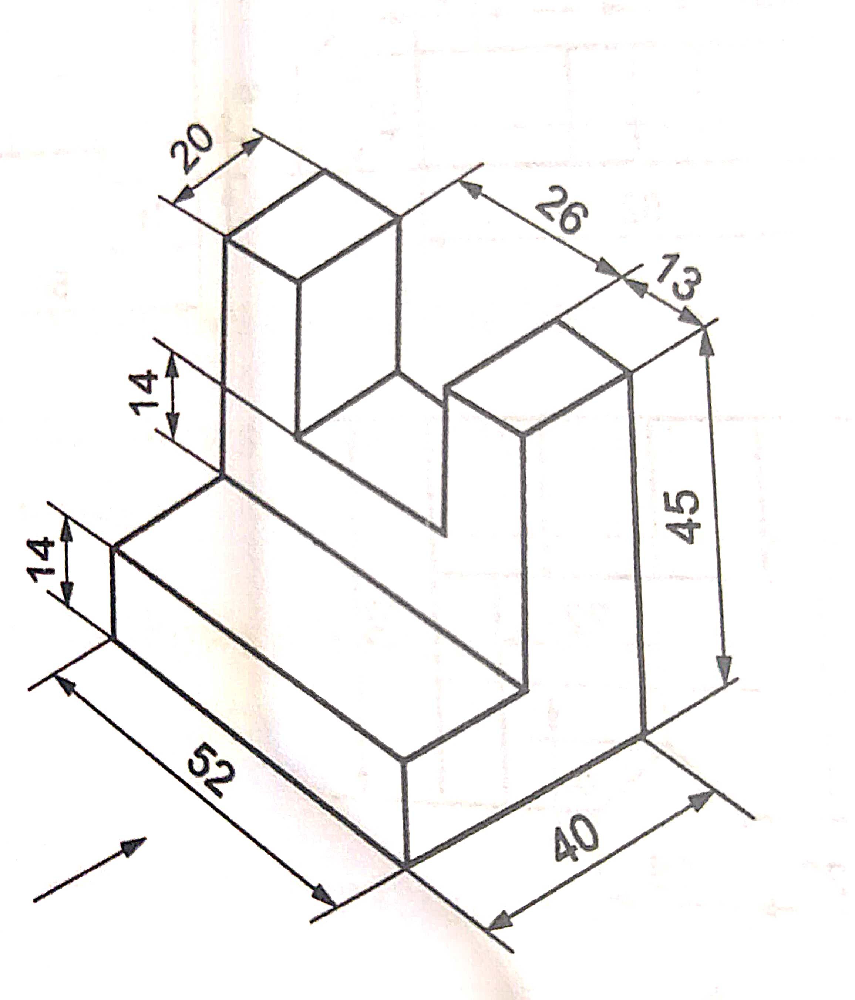 | L3 | CO6 | [8M]
 | OR
18 | Draw the Front view, Top view and Side view for following isometric view.  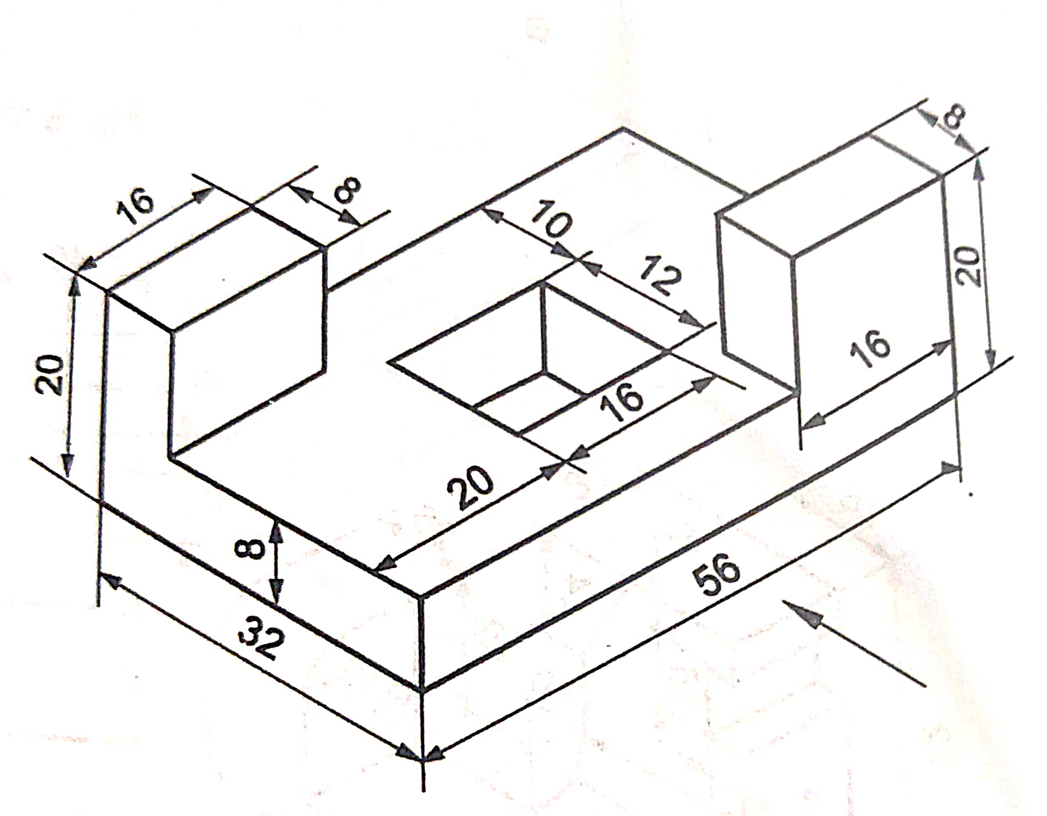 | L3 | CO6 | [8M]

-- 00 -- 00 –

